Post-unboxing work:
The nozzle is filled with moisturizing liquid during transportation, so the liquid must be drained first.
1. Open the front cover of the machine, then add purified or drinking water to the four ink tanks. Distribute one 500ml bottle of drinking water equally among the four ink tanks (distilled water is preferred; tap water and mineral water should not be used)
2. Open the front compartment cover, press the drip feeder above the spray head to add purified water, squeezing and releasing intermittently. Fill each color to half the water level.
(lightly pinch, using the siphon principle, to draw water from the ink tank to the printhead)
3. Lift the machine head, remove the silicone pad, and then place the small blue basin directly beneath the nozzle.
4. Connect only the power supply to the printhead, and press the small printhead switch on the side (located at the left rear position of the printhead). Each pressing lasts 5 seconds, followed by a 45-second interval before repeating. This process removes the humidifying liquid from the printhead. After 4-5 presses, observe the droplet flow from the printhead. If the flow is smooth—either as a continuous stream or rapid droplets—stop the pressing. Then, shake the ink tank with water to clean it and discard the remaining liquid.

After cleaning the moisturizing liquid, proceed with ink filling and pressure application, followed by printing the Flash test
5. Power off, add ink
6. Squeeze the pipette to draw in the ink, filling it halfway.
7. Connect the power supply to the printhead and press the small ink pressure switch on the side of the printhead (located at the rear left position facing the printhead). Each ink pressure cycle lasts 5 seconds, followed by a 45-second interval before repeating. This process expels water from the printhead. Perform 4-5 cycles and observe the droplet output from the printhead. If the ink flows smoothly as a continuous stream or falls in rapid droplets, and the color is a deep black mixed ink, the ink pressure process can be terminated.
8. Wet the non-woven cloth with warm water at 40-50 degrees Celsius, fold it, and gently wipe the surface of the nozzle.
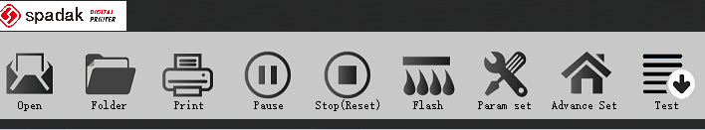
9. Lower the machine head to the material height, place an A4 sheet or cardboard directly beneath the nozzle, then click Flash. Immediately click again after 1 second

End the flash spray.
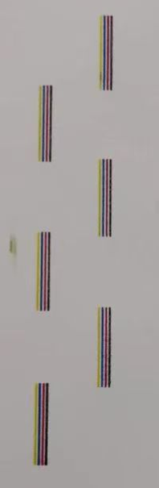
Observe the ink output on the paper and send it to us to determine whether further ink pressing is necessary. There are a total of 10 groups of nozzles, each with 4 colors. Observe for broken lines and color mixing. (After printing, please send it directly to us for viewing) as shown in the following picture.

11. Lower the laser sensor behind the machine head and shine it onto the conduction band. (Convenient for transportation, placed horizontally, adjusted to vertical)
12. Open the sensor cover, press the small button on the left to enter the sensing learning mode, place the material directly below the sensor, press it again, sense the material value and learn.
13. The sensor cannot be aligned with the hole in the tape guide. When printing paper cup sheets, the sensor should be adjusted to align with the front edge of the paper cup sheet.

Put in the materials and start printing
14. Raise the machine head, then power on the conduction band part, start the conduction band to see if it operates normally and if there are any foreign objects.
15. Wipe the nozzle again with warm water, then lower the nozzle and start the printing operation.
16. Importing images can be done by designing the size on the outside or adjusting the size for import. Retain the original dimensions as shown in the diagram:
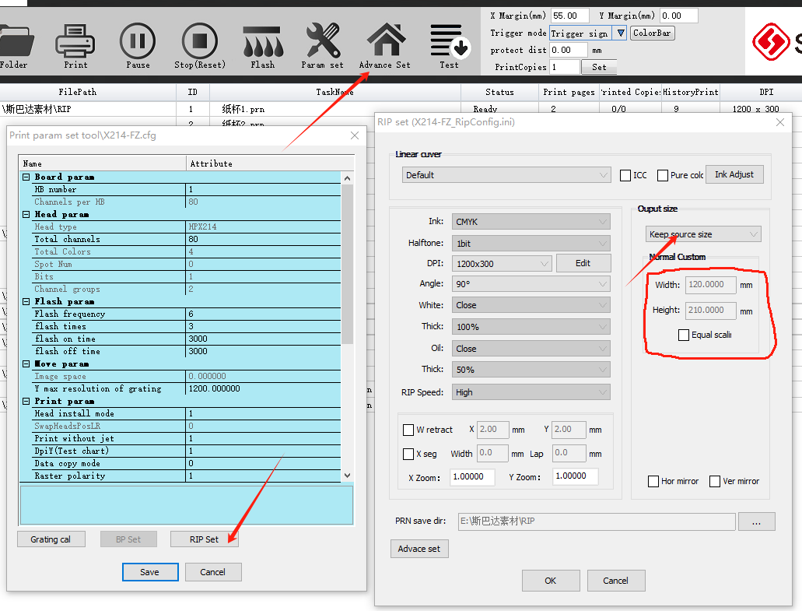
Change the size of the imported image as shown in the image-settings: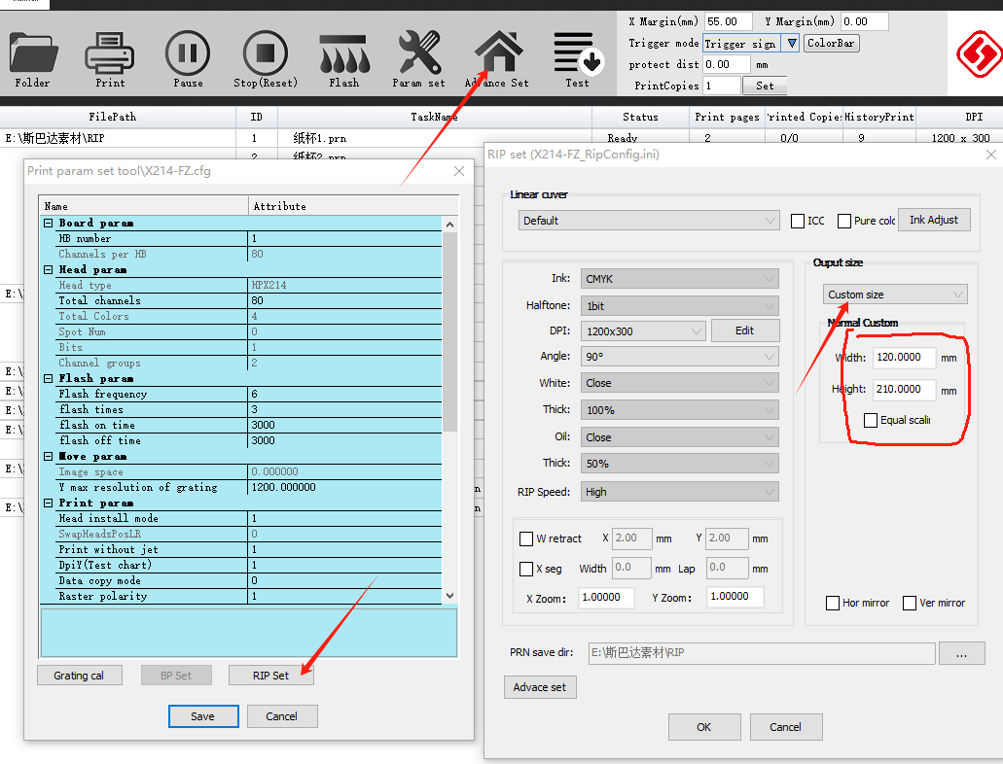

Note that changing the fixed size setting for imports will make all images uniform in size. Import the image as shown in the picture:
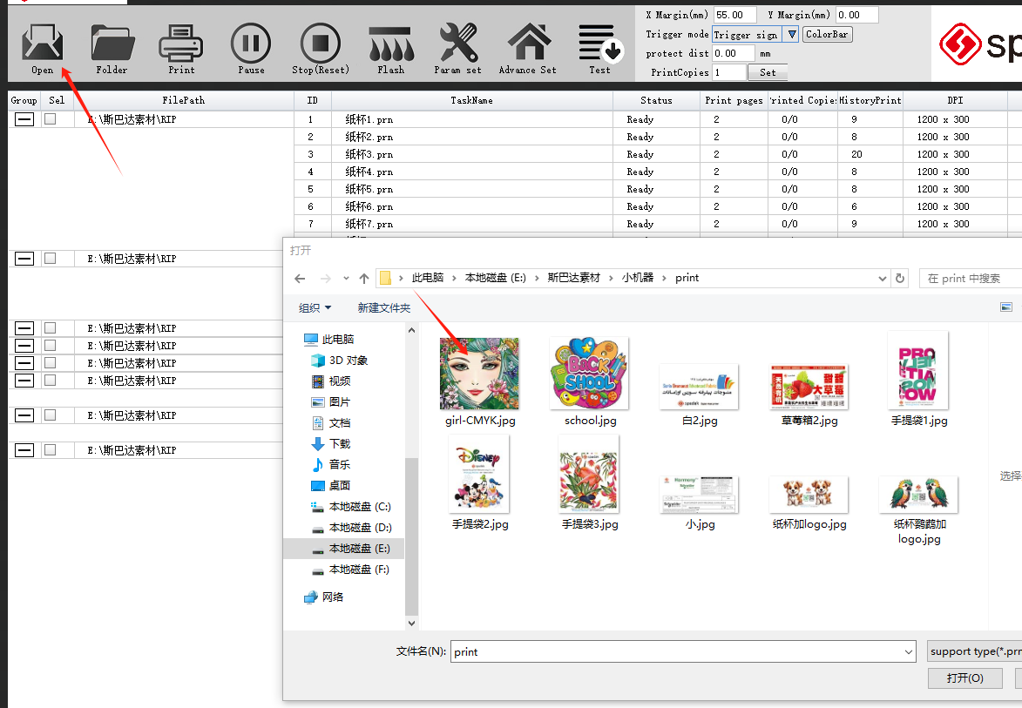
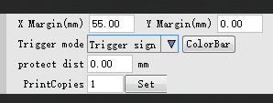

Adjust the image position,
X represents the distance between the material and the top, and Y represents the distance between the material and the printing starting point on the right side. The printed image deviates from the actual position as shown in the figure,Need to adjust the distance of XY.

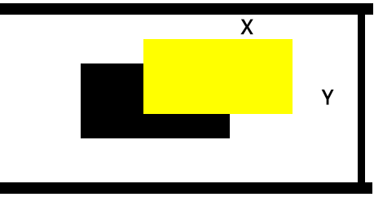

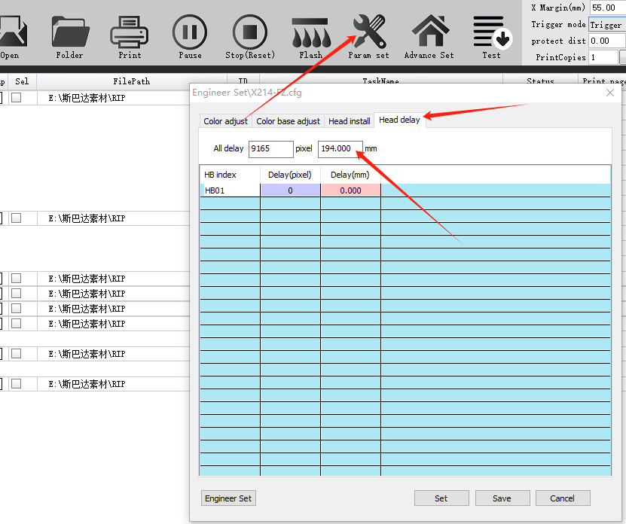
If the image on the image is close to the upper edge, increase X to move the image down, and if the image is close to the right edge on the right side, increase Y to move it left. When X is 0 and cannot be further reduced, adjust the material position (upward). When Y is 0 and cannot be reduced, as shown in the figure, adjust the response distance to reduce it. (Numerical distance from sensing head to nozzle)

18. After adjusting, try pagination, adjust the elasticity of the paginator, and then start printing.

