User Manual
Wireless Carplay Adapter
Android Auto Adapter

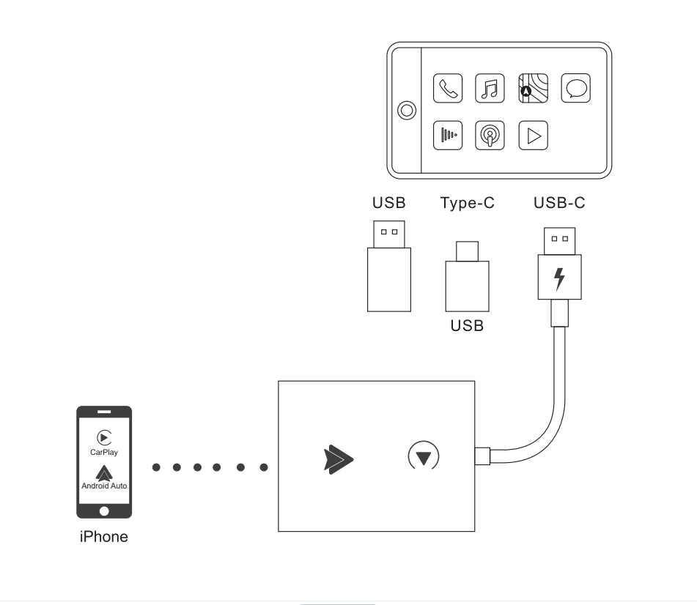

Please read the manual carefully before use Recommend keeping this manual for future reference
Compatibility Note
Please make sure your car supports wired carplay/Android Auto
Required iPhone6 or later iPhone models with IOS 10 or above for wireless carplay function
Required an Android smartphone that support latest Android Auto function and with Android 11 or higher of the Android operating system for wireless Android Auto function.
How to confirm if your car has Apple wired CarPlay or Android Auto function
Method 1:
Connect your iPhone or Android samrtphone to your car by USB date cable and see carplay or android auto logo on your car display
 or   or 
Method 2:
Check the compatible list below or check with your car manufacturer to see if your car has this capability:
Check out the website for supported car models


https://www.apple.com/ios/
carplay/available-models/
https.//www.android.com/auto
/Compatibility#Compatibility-vehicles

How to use
- Start the car and wait for the car head until system to be loaded

- Connect the Wireless Carplay Android auto adapter to the USB-A or USB-C port in your car.please be sure plug the adapter into the port that is for wired apple carplay or android auto.

3.Open WIFl and Bluetooth on your iPhone/Android samrtphone and find the Bluetooth named “smartAdapter_****”, Click on Pair; Click on 'Allow'; Click on Use Carplay or 'Use Android Auto'

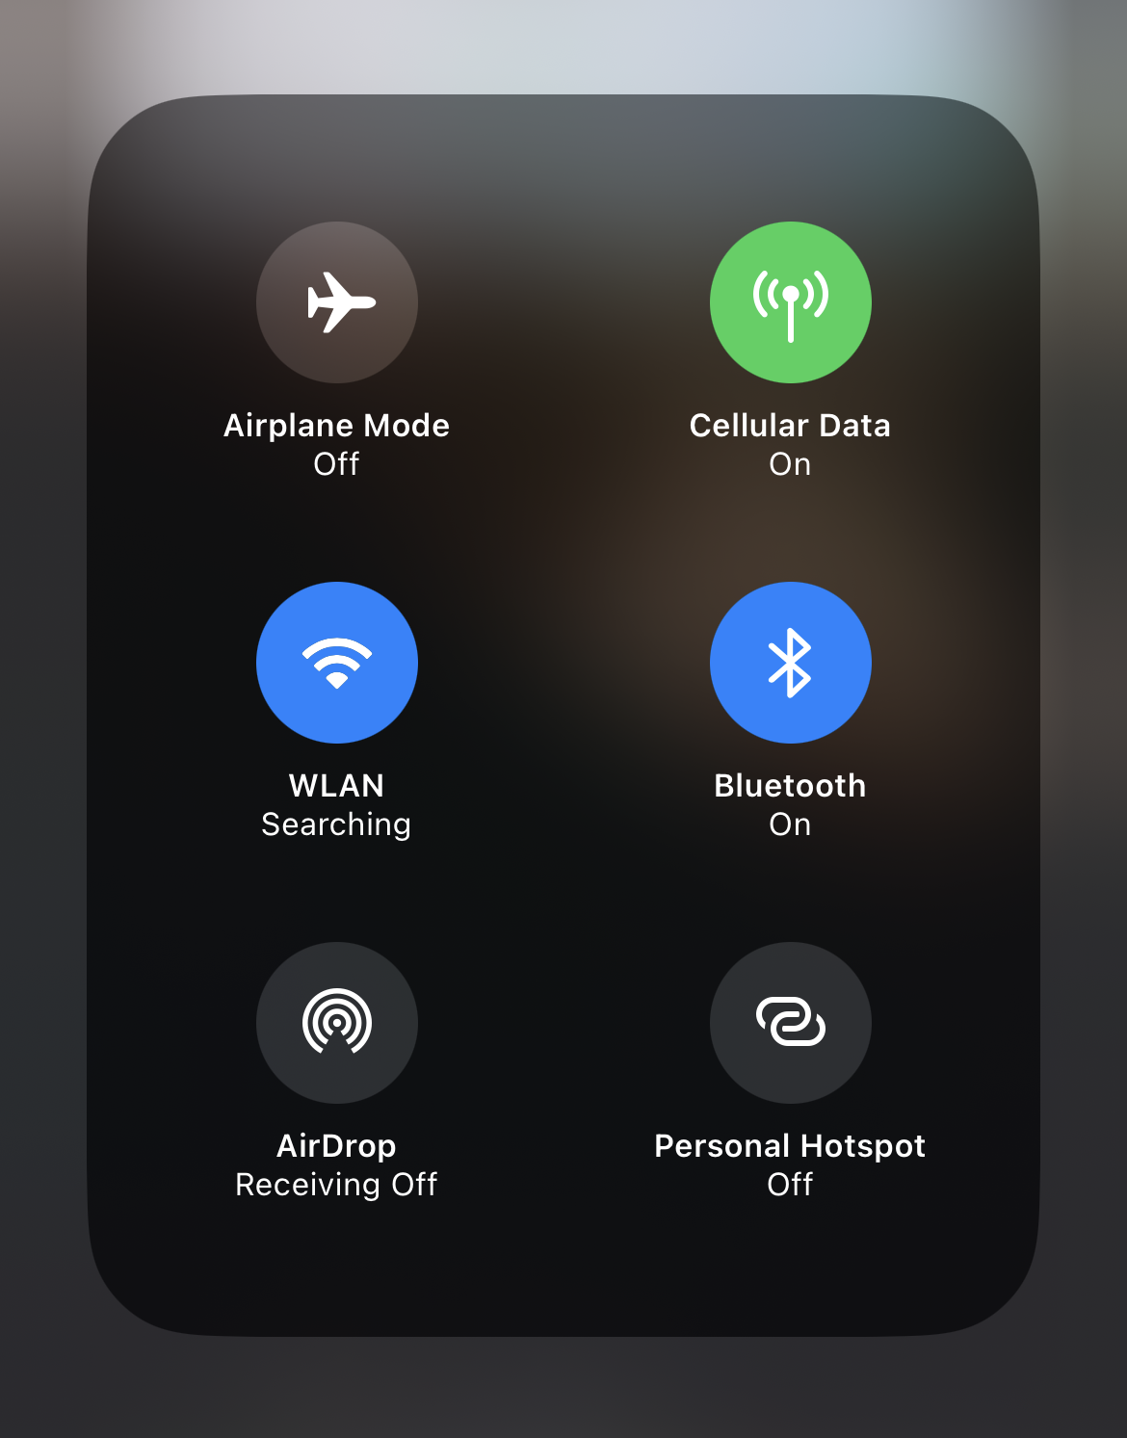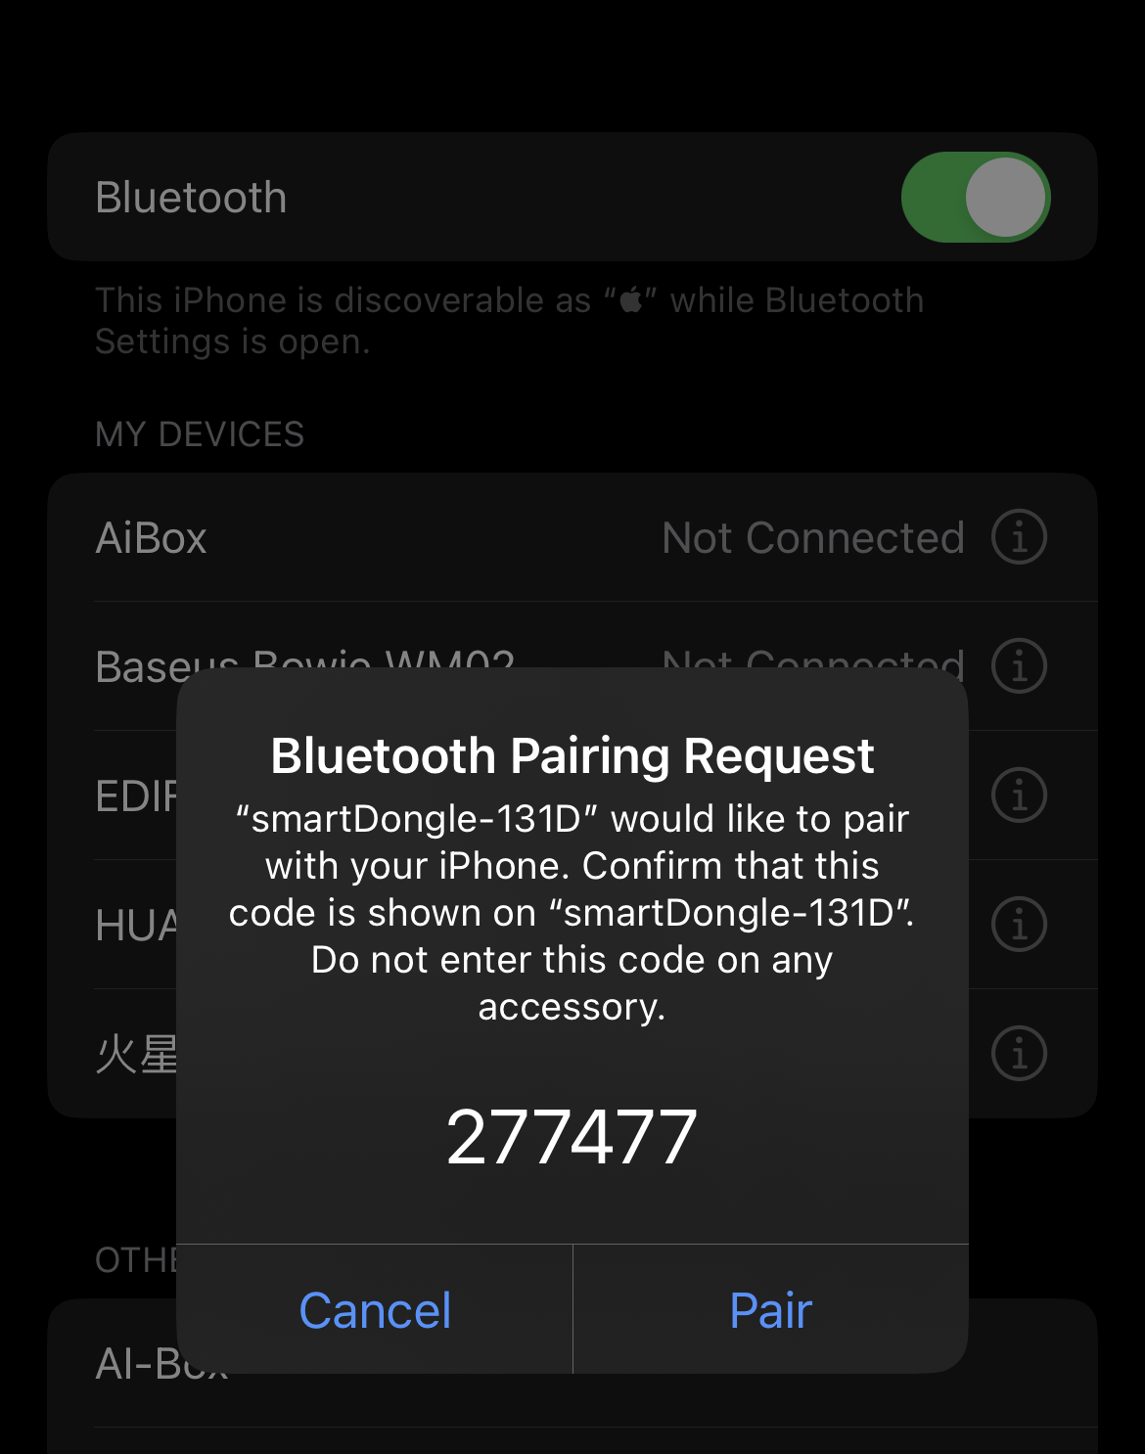

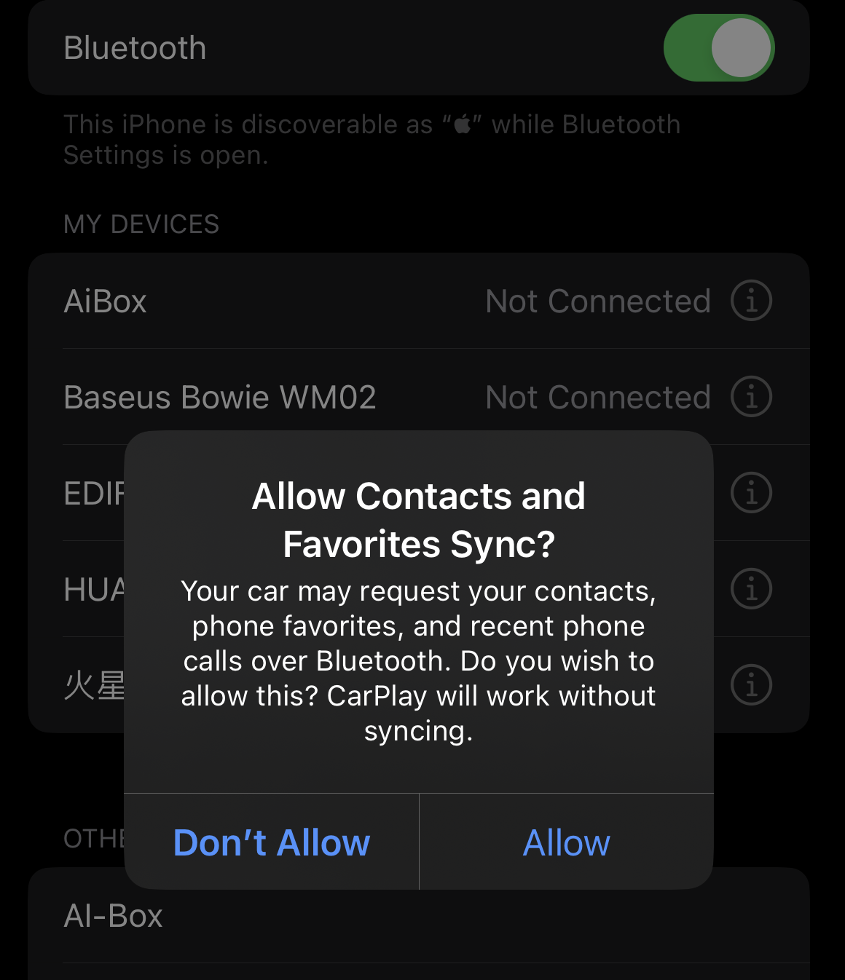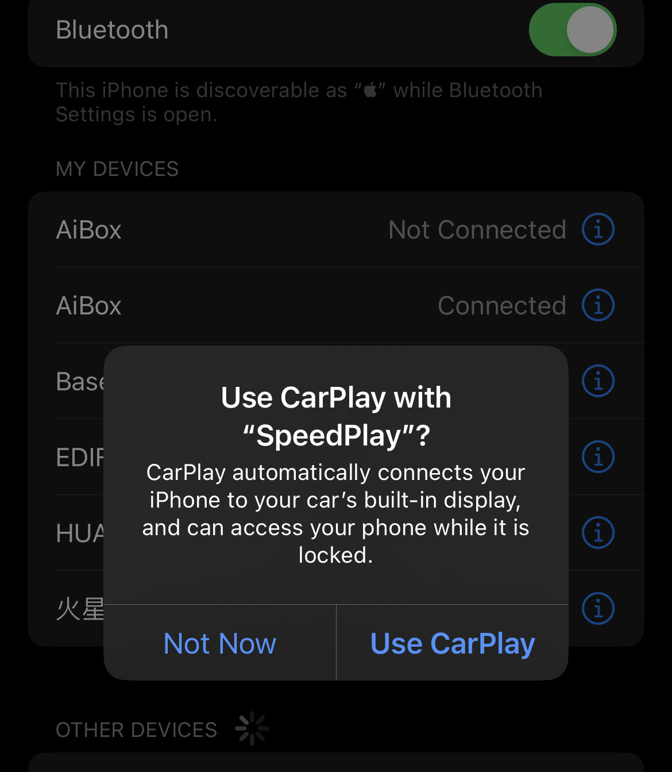

4:You are ready to enjoy wireless carplay or wireless Android Auto.

LED Light Description

Cyan status:Power on indicator

Green status:
1.Carplay connecting(green light fast flashing)
2.Carplay connected(green light slow flashing)

Blue status:
- Android connecting(Blue light fast flashing)
2.Android connected(Blue light slow flashing)
Please note
1.The wireless Carplay Android Auto adapter working principle is uses Bluetooth to establish a pairing between the iphone/ Android samrtphone and the vehicle, then switches to using WiFi to maintain the wireless connection After the Bluetooth pairing is successful, the iPhone/Androind smartphone WiFi will automatically connect to the adapter's WiFi, and then disconnect the Adapter Bluetooth connection by default for carplay and automatically connect to your vehicle Bluetooth by default for Android auto.
2.Please ensure wireless Carplay Androind auto Adapter power indicates blue light is on.
3.Please ensure that your car models supports wired carplay/Android auto
Package list
1xWireless Android Auto Adapter
1xUSB-AORUSB-COTGAdapter
1x3M Sticker
1xUser Manuel
FQA
1.What is the WiFi password for the Wireless
Carplay Adapter?
we need to connect the bluetooth,not Wi-Fi.After Bluetooth matching is successful,WiFi will automatically connect.
So no need Wi-Fi password.Make sure your Wi-Fi is turned on and unoccupied when pairing.

2.After pairing Android Auto adapter, can not start Android Auto function or compatible/ can not recognize the USB...

1)lf your car has use the android auto function for the first time,please use your date cable to connect your phone to activate android auto through a wired method

2)Please make sure that android auto on your android phone is the last version.lf not,please log in to your google play account to update to the latest version.

3)Please turn off the Bluetooth of your phone and enter the mobile application management to search auto to clear the auto cache.After the cleaning is completed,Restart the adapter and reconnect to Bluetooth.

3.Audio input or output issues : calls rejected or forwarded to voicemail/ no play sound /microphone not working/music playback interrupted or paused /voice functioning abnormally..

- Please check if the iphone/Android smartphone's Bluetooth connect to other devices such as Earphone, watch.....lf so Please disconnect other auto-connected Bluetooth devices or turn of the Bluetooth directly for carplay and connect to your vehicle bluetooth for android auto

- When on a call, check that your "Audio" output option is Carplay/Android Auto

4. The indicator light of the adapter is still on after the car is turned off.

we need to connect the bluetooth, not Wi-Fi.After Bluetooth matching is successful, WiFi will automatically connect.So no need Wi-Fi password. Make sure your Wi-Fi is turned on and unoccupied when pairing.

5.When use the wireless carplay Android Auto Adapter whether Mobile Phone can use other internet wifi

When enjoying the wireless android auto adapter function, the phone's WiFi will be occupied by the adapter, So you can not use other internet at the same time, You only can use your phone SIM card internet.

6.Unable to automatically reconnect

1)Please make sure that the Bluetooth and WiFi functions of your mobile phone are turned on and the Bluetooth is not occupied when you get in the car

2)Clear the pairing record , restart the phone and repair the
Adapter

7.Can the adapter be paired with multiple phones

The adapter can be palired with maximum five phones, but only one device can be connected at a time if you would like to pair it with a new phone , please cancel the current connection first Please note, by Bluetooth function default ,the adapter's system will only auto-connect back to the last used phone.

8.Can't find the bluetooth and Wi-Fi of the wireless Carplay Android Auto Adapter ?
Please make sure wireless Carplay Android auto adapter power indicates blue light is on and Be sure plug the adapter into the port that is for wired carplay/ Android auto.

lf convenient , Please test it with another Phone. lf only a specific phone cannot find the Bluetooth or Wi-Fi of the adapter please try to reset the network and bluetooth settings of this Phone and then restart the phone once , if the same problem happens on other Phone , lt will be defective,please let us know.

9.Whether Wireless Carplay Android auto Adapter support Youtube Video

1)Can not support Youtube for wireless carplay

- Can support Youtube for wireless Android Auto.Please follow operation Open Google Browser and type"AAADAPK"-----Download APK------Open“AAAD”----download”Carstream”-----Open”Carstream"go to setting and choose Enable desktop mode"after you can enjoy video from Youtube by wireless android auto Setting Video

link:https://www.youtube.com/watch?v=m8xHyEI9zXY 
Online update
● the adapter works properly, it means the current version is suitable for your car. lt is not recommended to update the firmware
● Only try this solution when the problem you cannot solve from the "FQA"
1.Power up the adapter
2.Connect the adapter's WiFi the password is"12345678"
3.Open web browser and enter"192.168.1.101" to enter the setting page and click"Online Update”for Carplay function
4. For Android auto,Please Click"Switch P2P"Then Click“OK"
5.Return to WiFi Connect, Find Wi-Fi Direct"option ,Then connect the Available devices(Smart Adapter-****) (This step is for reference only for Android phone users,if use iphone update the firmware, please ignore "Wi-Fi Direct step)
6.Return to the browser's page Click "“Update(PS: the signal light of will flash when it reached70%,and it will return to normal after successful
7.On the same page, you could also fill in the car brand, model ,years,and more details,next tap "Submit to report the issue. Our engineers will record your problem and research possible solutions
