EL1011F series 1-Port RJ45+1 optical Fast Industrial Media Converter

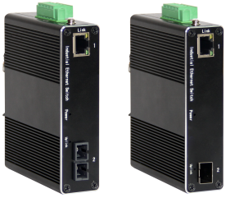
EL1011F is an optical convergence integrated Industrial Ethernet Media Converter independently developed by our company. This product is mainly developed for the application of point-to-point networks, star networks, tree networks, and chain networks in the industrial field. It support 1-Port 10/100Base-TX and 1-Port 100Base-FX, optional SFP, SC, ST, and FC interface, and the longest optical communication distance can reach 120KM.
In addition to its compact size, it has a high-performance switching engine, a wavy aluminum alloy shell with IP40 protection level, a fanless design and efficient heat dissipation surface, and an installed power input terminal over-current, over-voltage, the EL1011F Series features DC9-52 V redundant power inputs, DIN-rail mounting, high-level EMI/EMC capability, and an operating temperature range of -40°C to 75°C available. The EL1011F Series has also passed a 100% burn-in test to ensure it will function reliably in the field. Therefore, it can provide reliable and convenient solutions for users’ Ethernet equipment networking.
Interface
- 1*10/100BaseT(X),Automatic detection, Full/half duplex MDI/MDI-x adaptive
- 1*100Base-FX Port (SC/FC/ST/SFP optional)
Industrial conformance
- 9V to 52V DC, redundant power input
- -40℃ to 75℃ operating temperature
- IP40 aluminum housing
- Supports 6KV DC Ethernet ESD protection
- Supports 6KV DC EFT protection for power line
- Free Fall, Shock and Vibration Stability
- DIN-rail hardware design
SPECIFICATIONS:
Product Name | 1-Port RJ45+1-Port optical Fast Industrial Media Converter
Model No. | EL1011F
Ethernet interface
RJ45 Port | 1*10/100BaseT(X),Automatic detection, Full/half duplex MDI/MDI-x adaptive
Optical port | 1*100Base-FX Port(SC/FC/ST/SFP optional)
Power Parameters
Power | Connection: 1 removable 5-contact terminal block(s)  Input voltage: DC9 to 52V redundant power support reverse connection protection
LED Indicator | Power: Green  Link: Green
Standards
Network Protocols | IEEE802.3 10BASE-T;100BASE-T IEEE802.3i 10Base-T;IEEE802.3u;IEEE802.3x;
Twisted Pair | 10BASE-T: Cat3,4,5 UTP(≤100 meter)  100BASE-TX: Cat5 or later UTP(≤100 meter)
Switch Properties
Processing Type: | Store and Forward
MAC Table Size | 2K
Packet Buffer Size | 1Mbit
Bandwidth | 1.6G
Switching Delay | ＜10μs
Power Consume | ＜3W
Physical Characteristics
Protection level | IP40
Enclosure | Wavy aluminum alloy
Installation | Push-in DIN rail
Weigh | 0.38kg
Dimensions | 115x70x30mm （length x width x height)
Environmental Limits
Working temperature | -40～75℃ （-40～167°F）
Storage Temperature (package included) | -40 to 85°C (-40 to 185°F)
Ambient Relative Humidity | 5 to 95% (non-condensing)
Standards and Certifications
Safety | EN 62368-1(LVD)
EMI | FCC Part 15 Subpart B Class A，EN 55032 Class A
EMS | IEC(EN)61000-4-2(ESD): ±8kV Contact, ±8kV Indirect,±15kV Air  IEC(EN)61000-4-3(RS):10V/m(80～1000MHz)  IEC(EN)61000-4-4(EFT): power line:±4kV; data line:±2kV  IEC(EN)61000-4-5(Surge): power:±6kV CM/±4kV DM; data:±4kV  IEC(EN)61000-4-6(RF conduction):3V(10kHz～150kHz),10V(150kHz～80MHz)  IEC(EN)61000-4-16(Common mode conduction):30V cont. 300V,1s  IEC(EN )61000-4-8
Shock | IEC 60068-2-27
Freefall | IEC 60068-2-32
Vibration | IEC 60068-2-6
MTBF
Time | 300 000hrs
Warranty
Warranty Period | 5years
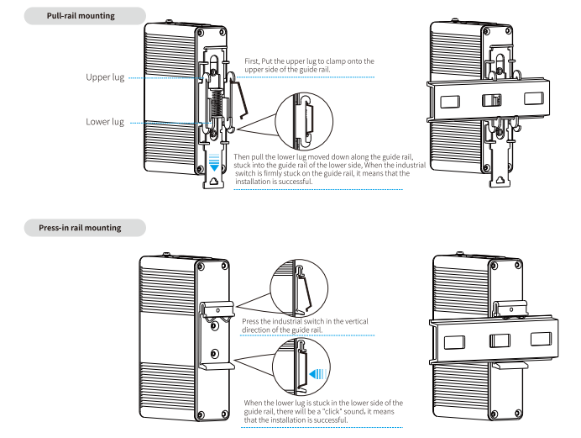
Installation method

Order Information
Specification | Model No.
1 Port 10/100Base TX+1 Port 100 Base FX SFP Industrial media convertor | EL1011F-SFP
1 Port 10/100Base TX+1 Port 100 Base FX Port(multi-mode SC connector) 2KM distance | EL1011F-SC2
1 Port 10/100Base TX+1 Port 100 Base FX Port (single-mode SC connector)  20KM distance | EL1011F-SC20  EL1011F-SC20A / SC20B
1 Port 10/100Base TX+1 Port 100 Base FX Port (multi-mode ST connector)2KM distance | EL1011F-ST2
1 Port 10/100Base TX+1 Port 100 Base FX Port (single-mode ST connector)  20KM distance | EL1011F-ST20  EL1011F-ST20A / ST20B
1 Port 10/100Base TX+1 Port 100 Base FX Port (multi-mode FC connector)2KM distance | EL1011F-FC2
1 Port 10/100Base TX+1 Port 100 Base FX Port (single-mode FC connector)  20KM distance | EL1011F-FC20  EL1011F-FC20A / FC20B

