EL242GSMI

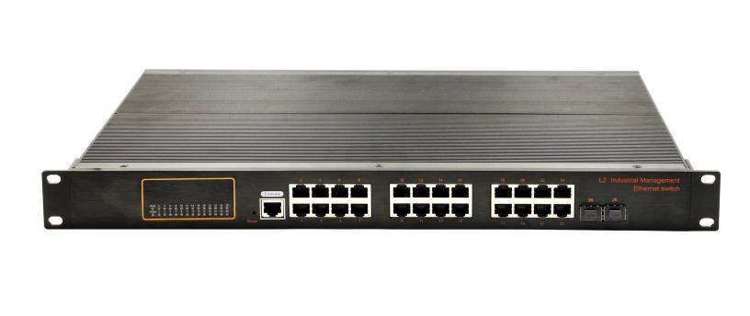
24-Port RJ45+2G SFP L2 Managed Industrial Switch

EL242GSMI an hardened 26-port Industrial Ethernet Switch, provides non-blocking wire-speed performance in harsh industrial environment. It also provides 24-port 10/100/1000BASE-TX RJ45 +2G SFP delivered in an IP40 rugged, strong case with redundant power system. It’s suitable for such applications as surveillance system deployments, control management and wireless service in climatically demanding environments with wide temperature range from -40℃ to 75℃
Interface
- 24-port 10/100/1000Base-Tx RJ-45 with auto negotiation and auto-MDI/ MDI-X function
- 2G SFP uplink (automatically 100Mbps/1000Mbps SFP module)
Industrial conformance
- AC110-240V redundant power input
- - 40℃ to 75℃ operating temperature
- IP40 aluminum housing
- Supports ESD protection: contact 8KV, air 12KV
- Supports Surge protection: CM±4KV, DM±2KV
- Free Fall, Shock and Vibration Stability
- 19“ Rak-mountable hardware design

The EL242GSMI provides the flexibility to all kinds of 10/100/1000Mbps Ethernet Media on SFP port and performs highly stable fiber performance

The EL242GSMI is packaged in a compact IP40 case that allows bracket mounting to cabinet. It provides power supply AC100-240V input
SPECIFICATIONS:
Model No. | EL242GSMI
1000Base-TX Port | 24 Port 10/100/1000 RJ45
1000Base-FX Port | 2G SFP 100/1000
Performance Specification | Bandwidth: 56Gbps  Packet Buffer Memory: 12Mbit  Packet Forwarding Rate: 42Mpps  MAC Address Table: 8K
Installation | Rak mounted
Maximum Frame Size | 10240bytes packet size
Flow Control | Back pressure for half duplex, IEEE 802.3x pause frame for full duplex
Enclosure | IP40 Aluminum housing
LED Indicator | Power: Red  Fiber: Link (Green)  Ethernet: Yellow
Power Input | AC110-240V  Supports built-in over-current 4.0A protection  Supports reverse connection protection
Power Consumption | < 20W
Surge protection | ± 4KV
Network Protocols | IEEE802.3 10BASE-T;  IEEE802.3i 10Base-T;  IEEE802.3u;100Base-TX/FX;  IEEE802.3ab 1000Base-T;  IEEE802.3z 1000Base-X;  IEEE802.3x;
Network cables | 10BASE-T: Cat3,4,5 UTP(≤100 meter)  100BASE-TX: Cat5 or later UTP(≤100meter)  1000BASE-TX: Cat6 or later UTP(≤100 meter)
Industry Standard | FCC CFR47 Part 15,EN55032 Class A  IEC61000-4-2 (ESD): ±8kV (contact), ±12kV (air)  IEC61000-4-3 (RS): 10V/m (80~1000MHz)  IEC61000-4-4 (EFT): Power Port: ±4kV; Data Port: ±2kV  IEC61000-4-5 (Surge): Power Port: ±2kV/DM, ±4kV/CM; Data Port: ±2kV  IEC61000-4-6 (CS): 3V (10kHz-150kHz); 10V (150kHz-80MHz)  IEC61000-4-16 (Common mode conduction): 30V (cont.), 300V (1s)
MTBF | 300,000hours
Dimensions (W x D x H) | 442×325×44mm
Weight | Product Weight: 3.2KG  Packing Weight: 4KG
Working Environment | Working temperature: -40～75℃ ;  Storage temperature: -40～75℃  Relative Humidity: 5%~95 %( no condensation)
SOFTWARE:
Port Features | IEEE 802.3x Flow control
Port Features | Interface counters
Port Features | Storm Control
Link Aggregation | Static Aggregation
Link Aggregation | Dynamic Aggregation, LACP
Link Aggregation | Supports up to 4 aggregation groups, each group up to 8 ports  Load balancing
MAC Address Table | Static MAC Address  MAC Binding
Mirroring | Port-based  One-to-one Mirroring, Many-to-one Mirroring
Spanning Tree | IEEE802.1d STP
Spanning Tree | IEEE802.1w RSTP
Spanning Tree | IEEE802.1s MSTP
ERPS (G.8032) | Single Ring, Sub-Ring, Multi-Ring
ERPS (G.8032) | Recovery Time < 50ms
LLDP | LLDP
LLDP | LLDP-MED
Loop Protection | Supported
VLAN | 4094 VLAN
VLAN | Port-based VLAN
VLAN | GVRP
Protocol VLAN | MAC-based VLAN
Protocol VLAN | IP Subnet-based VLAN
Protocol VLAN | Voice VLAN
Port Isolate | Support
IGMP | Snooping IGMP V1 Snooping
IGMP | IGMP V2 Snooping
IGMP | IGMP V3 Snooping
IGMP | Source Port Check
IGMP | IGMP Fast Leave
IGMP | IGMP Filter
MLD Snooping | MLD V1 Snooping
MLD Snooping | MLD V2 Snooping
MLD Snooping | Source Port Check
MLD Snooping | MLD Fast Leave
MLD Snooping | MLD Filter
Security
ACL | ACL (IP Standard ACL), IPv4/IPv6
ACL | MAC extend ACL
ACL | IP extend ACL
ACL | L2, L3, L4 fields match
ACL | log, redirection, mirroring, speed limit
QoS | QoS Class, Remarking
QoS | SP, WRR queue scheduling
QoS | Ingress port-based rate-limit
QoS | Ingress priority-based rate-limit
QoS | Egress port-based rate-limit
QoS | Egress queue-based rate-limit
QoS | Policy-based QoS
QoS | Storm Control
QoS | 8 queues per port
802.1X | Port-based
User management | Password protection
SNMP | SNMP V1/V2c/V3
RMON | Statistics Group
RMON | History Group
RMON | Alarm Group
RMON | Events Group
Web management | HTTP V1.1, HTTPS
Firmware Upgrade | Reversion Upgrade
IPv4/IPv6 | Support
CLI | Support
Syslog/Debug | Support
Diagnosis | Ping (IPv4), ping (IPv6)
Diagnosis | Trace route(IPv4)
Management
NTP | NTP Client
DHCP | DHCPv4 Client, DHCPv6 Client
DHCP Snooping | DHCP snooping table
DHCP Snooping | Trust Port
Telnet | Telnet Server
TFTP | TFTP Client
SSH | SSH Server
Dimensions

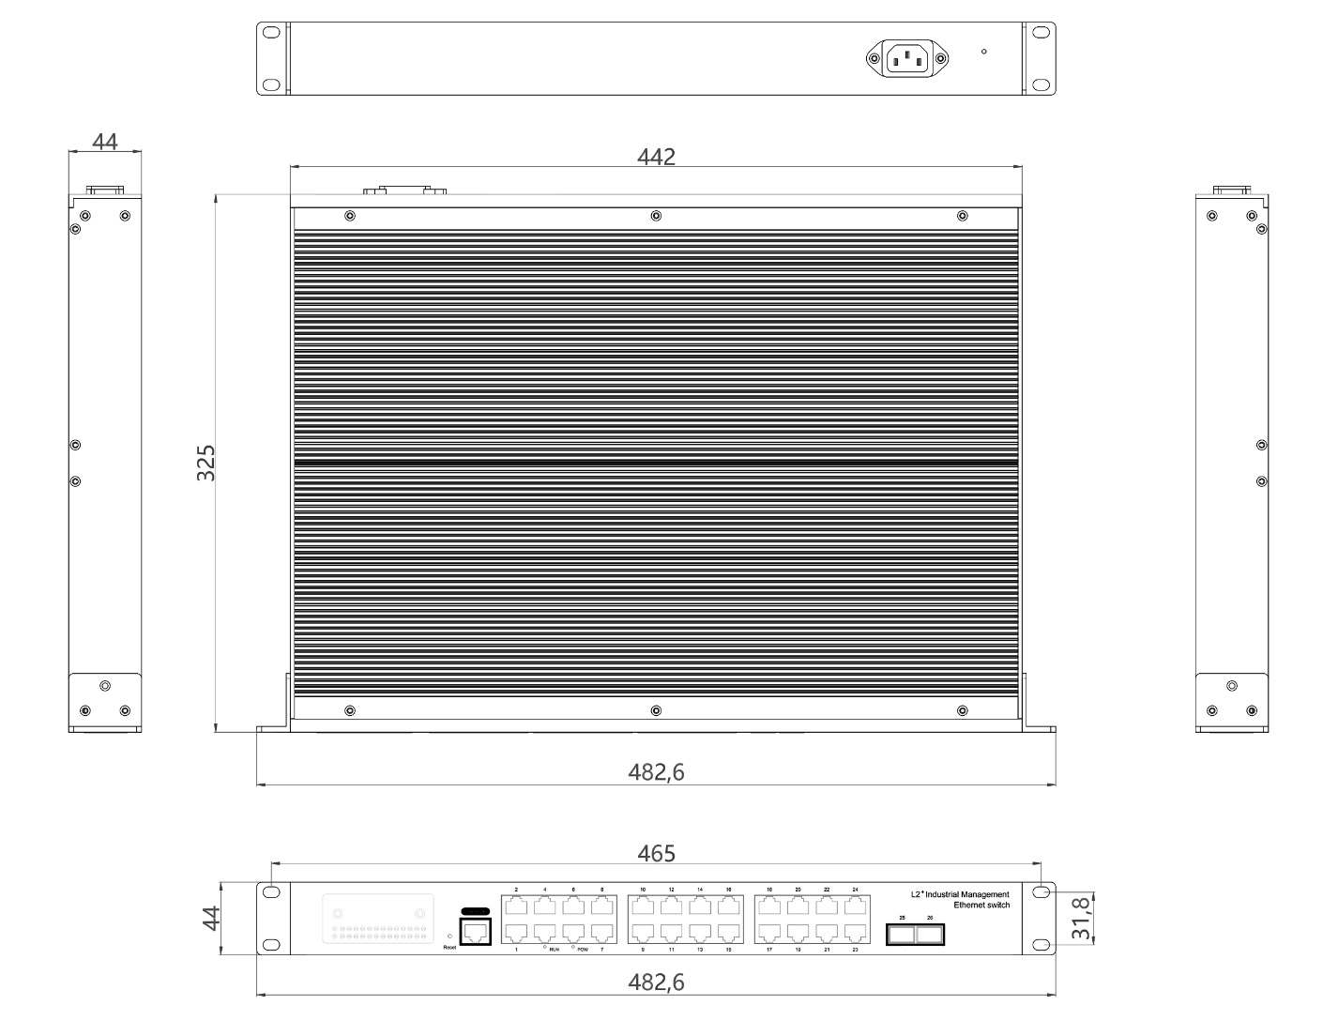

Ordering Information
EL242GSMI | 24-Port 10/100/100BASE-TX+2G SFP Managed Industrial Switch

