EL244GTS 24-Port Gigabit +4*10G SFP L3 Managed Industrial Switch
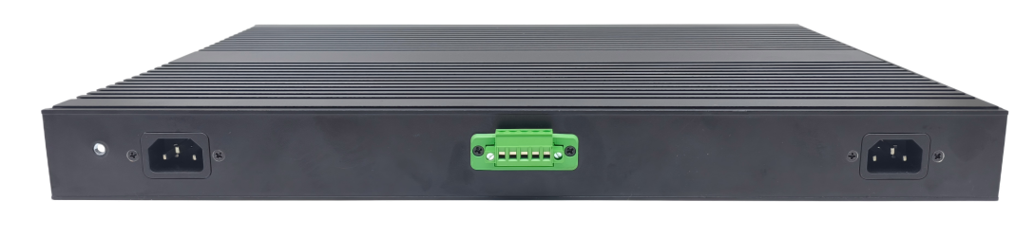
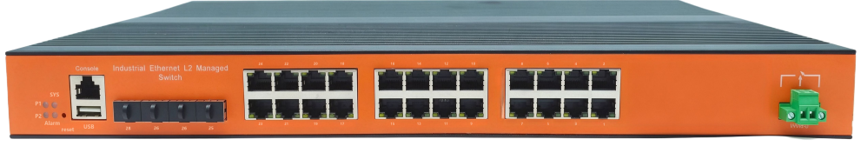

EL244GTS is a photoelectric convergence integrated Industrial Ethernet Gigabit Managed switch .This product is mainly developed for the application of point-to-point network, star network, tree network, chain network and ring network in the industrial field. With 24 x 10/100/1000Base-TX ports, 4x10G SFP optical ports, all ports support full wire-speed forwarding, and its high-performance switching engine, and has a redundant self-healing ring (fault recovery time＜20ms) to realize single loop, tangent, and intersection loop protocols, support for broadcast storm suppression, port mirroring, port priority QoS settings, port aggregation functions. IP40 rated enclosure, fanless design with highly efficient wavy aluminum alloy shell heat dissipation surface, overcurrent, overvoltage and EMC protection for power inputs, excellent EMC protection for RJ45 ports, to make products work efficiently in harsh industrial environments. And it can provide a reliable and convenient solution for the users’ Ethernet equipment networking.
Product features:
● Data control: Supports 802.3x full-duplex flow control and
network storm suppression
● Redundant network: supports STP, RSTP, MSTP and ERPS (self-healing time <20ms)
● Redundancy backup: supports the virtual route redundancy protocol VRRP
● Multicast management: Support IGMP Snooping V1, V2, and V3
● VLAN: supports IEEE 802.1Q vlans to effectively isolate broadcast domains
Link aggregation: Support static/dynamic link aggregation, provide perfect bandwidth utilization
● QOS: Support COS\DSCP, 4 queues, support WRR\SP scheduling mode
● Security management: Security management: supports ACL and 802.1x
● Management: Supports WEB, CLI, and SNMP management
Monitoring and maintenance: Support port mirroring, interface status monitoring, log management
SPECIFICATIONS:
Product Name | 24-Port RJ45 +4*10G SFP L3 Managed Industrial Switch
Model No. | EL244GTS
Interface
RJ45 Port | 24*10/100/1000BaseT(X),Automatic detection, Full/half duplex MDI/MDI-x adaptive
Optical port | 4*1000/10000Base-FX SFP
Console | RS232
USB | USB2.0
DI/DO | Relay output, purely resistive load: 5A@30VDC; 8A@250VAC
Reset | Short press to reset, long press to restore factory settings
Power Parameters
Power | Redundant power Input (DC polarity reverse connection protection and overcurrent protection)  Support any two of following power input:  A:100-240VAC,50/60Hz;110-220VDC (85-264VAC/77-300VDC) ,  B:48VDC (36-75VDC)  C::12V/24V/36V/48VDC(9.6~60VDC)  Power consumption: max.45W
LED Indicator | Power indicator LED : Green PWR  Alarm output LED: Yellow Alarm  System indicator LED: Green SYS  RJ45(Green) Link/Act  SFP(Green) Ulink/Act
Standards
Network Protocols | IEEE802.3-10BaseT,IEEE802.3u-100BaseTX/100Base-FX,IEEE802.3x-Flow Control,IEEE802.3z-1000BaseLX,IEEE802.3ab-1000BaseTX,IEEE802.1ab Logical Link Discovery Protocol,IEEE802.1D-Spanning Tree Protocol,IEEE802.1w-Rapid Spanning Tree Protocol, APS ,IEEE802.1Q -VLAN Tagging, IEEE802.1p -Class of Service,IEEE802.1X-Port Based Network Access Control
Twisted Pair | 10BASE-T: Cat3,4,5 UTP(≤100 meter)  100BASE-TX: Cat5 or later UTP(≤100 meter)  1000BASE-TX: Cat6 or later UTP(≤100 meter)
Switch Properties
Processing Type: | Store and Forward
Capacity | 128Gbps
Packet forwarding rate | 95.232Mpps
MAC Table Size | 16K
Packet Buffer Size | 12Mbit
Jumbo Frame | 12KB
Vlan | 4K
Physical Characteristics
Protection level | IP40
Enclosure | Wavy aluminum alloy
Installation | Rack mount
Weigh | 6kg
Dimensions | 440x304x44mm (L*W*H)
Environmental Limits
Working temperature | -40～75°C（-40～167°F）
Storage Temperature (package included) | -40 to 85°C (-40 to 185°F)
Ambient Relative Humidity | 5 to 95% (non-condensing)
Standards and Certifications
Safety | EN 62368-1(LVD)
EMI | FCC Part 15 Subpart B Class A EN 55032 Class A
EMS | IEC(EN)61000-4-2(ESD): ±8kV Contact, ±8kV Indirect,±15kV Air  IEC(EN)61000-4-3(RS):10V/m(80～1000MHz)  IEC(EN)61000-4-4(EFT): power line:±4kV; data line:±2kV  IEC(EN)61000-4-5(Surge): power:±6kV CM/±4kV DM; data:±4kV  IEC(EN)61000-4-6(RF conduction):3V(10kHz～150kHz),10V(150kHz～80MHz)  IEC(EN)61000-4-16(Common mode conduction):30V cont. 300V,1s  IEC(EN )61000-4-8
Shock | IEC 60068-2-27
Freefall | IEC 60068-2-32
Vibration | IEC 60068-2-6
MTBF
Time | 300 000hrs
Warranty
Warranty Period | 5years
SOFTWARE:
Port Features | IEEE 802.3x Flow control
Port Features | Interface counters
Port Features | Storm Control
Link Aggregation | Static Aggregation
Link Aggregation | Dynamic Aggregation, LACP
Link Aggregation | Supports up to 4 aggregation groups, each group up to 8 ports  Load balancing
MAC Address Table | Static MAC Address  MAC Binding
Mirroring | Port-based  One-to-one Mirroring, Many-to-one Mirroring
Spanning Tree | IEEE802.1d STP
Spanning Tree | IEEE802.1w RSTP
Spanning Tree | IEEE802.1s MSTP
ERPS (G.8032) | Single Ring, Sub-Ring, Multi-Ring
ERPS (G.8032) | Recovery Time < 50ms
LLDP | LLDP
LLDP | LLDP-MED
Loop Protection | Supported
VLAN | 4094 VLAN
VLAN | Port-based VLAN
VLAN | GVRP
IGMP | Snooping IGMP V1 Snooping
IGMP | IGMP V2 Snooping
IGMP | IGMP V3 Snooping
IGMP | Source Port Check
IGMP | IGMP Fast Leave
Security
ACL | ACL (IP Standard ACL), IPv4/IPv6
ACL | MAC extend ACL
ACL | IP extend ACL
ACL | L2, L3, L4 fields match
QoS | QoS Class, Remarking
QoS | SP, WRR queue scheduling
QoS | Ingress port-based rate-limit
QoS | Ingress priority-based rate-limit
QoS | Egress port-based rate-limit
QoS | Egress queue-based rate-limit
QoS | Policy-based QoS
QoS | Storm Control
QoS | 8 queues per port
802.1X | Port-based
User management | Password protection
SNMP | SNMP V1/V2c/V3
RMON | Statistics Group
RMON | History Group
RMON | Alarm Group
RMON | Events Group
Web management | HTTP V1.1, HTTPS
Firmware Upgrade | Reversion Upgrade
CLI | Support
Syslog/Debug | Support
Diagnosis | Ping (IPv4), ping (IPv6)
Diagnosis | Trace route(IPv4)
Management
NTP | SNTP
Telnet | Telnet Server
TFTP | TFTP Client
SSH | SSH Server

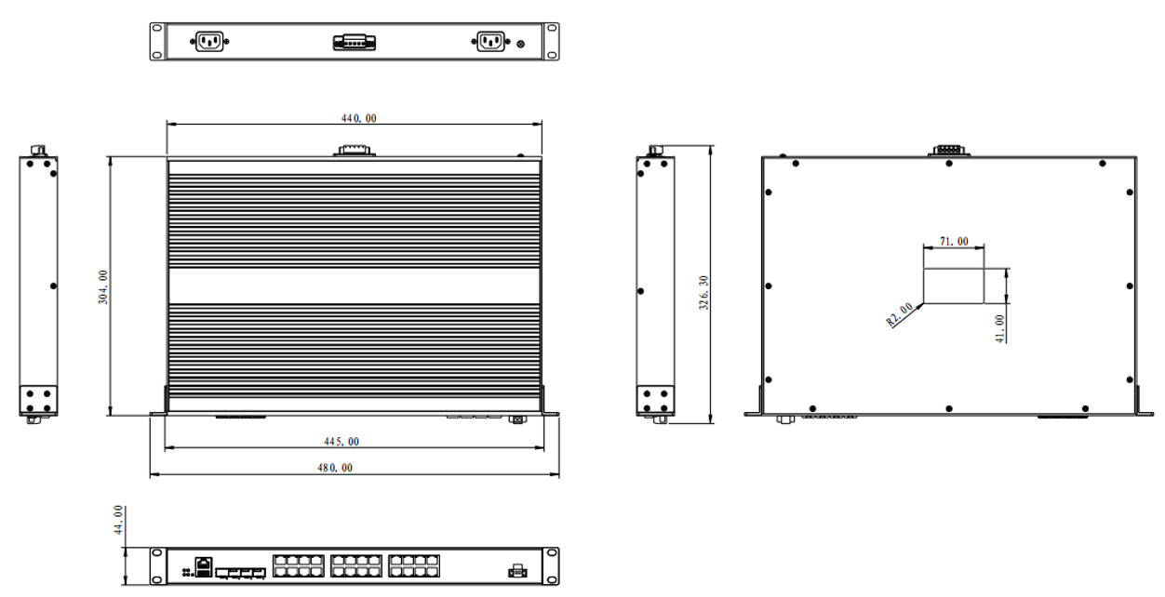

Order Information
Specification | Model No.
L3 Managed Industrial Switch  24 Port 10/100/1000Base TX+4 Port 10G/1G SFP | EL244GTS

