EL84MGI V3 8-Port RJ45 +4G SFP L2 Managed Industrial Switch

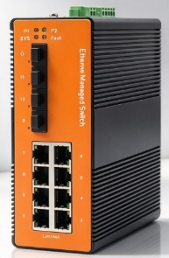
EL84MGI V3 is an optical convergence integrated Managed Industrial Ethernet Switch independently developed by our company. This product is mainly developed for the application of point-to-point networks, star networks, tree networks, and chain networks in the industrial field. It supports 8-Port 10/100/1000Base-TX and 4-Port 100/1000Base-FX SFP, and the longest optical communication distance can reach 120KM.
In addition to its compact size, it has a high-performance switching engine, a wavy aluminum alloy shell with IP40 protection level, a fanless design and efficient heat dissipation surface, and an installed power input terminal over-current, over-voltage, the EL84MGI V3 features DC12-52V redundant power inputs, DIN-rail mounting, high-level EMI/EMC capability, and an operating temperature range of -40 to 75°C available. The EL84MGI V3 has also passed a 100% burn-in test to ensure it will function reliably in the field. Therefore, it can provide reliable and convenient solutions for users’ Ethernet equipment networking.
Interface
- 8*10/100/1000BaseT(X), Automatic detection, Full/half duplex MDI/MDI-x adaptive
- 4*100/1000Base-FX Port SFP
Industrial conformance
- 12V to 52V DC, redundant power input
- -40℃ to 75℃ operating temperature
- IP40 aluminum housing
- Supports 6KV DC Ethernet ESD protection
- Supports 6KV DC EFT protection for power line
- Free Fall, Shock and Vibration Stability
- DIN-rail hardware design
SPECIFICATIONS:
Product Name | 8-Port RJ45 +4G SFP L2 Managed Industrial Switch
Model No. | EL84MGI V3
Ethernet interface
RJ45 Port | 8*10/100/1000BaseT(X),Automatic detection, Full/half duplex MDI/MDI-x adaptive
Optical port | 4*100/1000Base-FX SFP
Power Parameters
Power | Connection: 1 removable 5-contact terminal block(s)  Input voltage: DC12 to 52V redundant power support reverse connection protection
Relay out put | 1 set of alarm output relay output
LED Indicator | Power LED: Red PWR1, PWR2  System LED: Green SYS  Interface LED: RJ45 yellow PoE indicator, green Link/Act indicator  fiber port green Link/Act indicator
Standards
Network Protocols | IEEE802.3-10BaseT,IEEE802.3u-100BaseTX/100Base-FX,IEEE802.3x-Flow Control,IEEE802.3z-1000BaseLX,IEEE802.3ab-1000BaseTX,IEEE802.1ab Logical Link Discovery Protocol,IEEE802.1D-Spanning Tree Protocol,IEEE802.1w-Rapid Spanning Tree Protocol, APS ,IEEE802.1Q -VLAN Tagging, IEEE802.1p -Class of Service,IEEE802.1X-Port Based Network Access Control
Twisted Pair | 10BASE-T: Cat3,4,5 UTP(≤100 meter)  100BASE-TX: Cat5 or later UTP(≤100 meter)  1000BASE-TX: Cat6 or later UTP(≤100 meter)
Switch Properties
Processing Type: | Store and Forward
Packet forwarding rate | 17.856Mpps
MAC Table Size | 8K
Packet Buffer Size | 128Kbit
Bandwidth | 26G
Switching Delay | ＜10μs
Power Consume | ＜15W
Physical Characteristics
Protection level | IP40
Enclosure | Wavy aluminum alloy
Installation | Push-in DIN rail
Weigh | 0.9kg
Dimensions | 150x114x53mm (L*W*H)
Environmental Limits
Working temperature | -40～75°C（-40～167°F）
Storage Temperature (package included) | -40 to 85°C (-40 to 185°F)
Ambient Relative Humidity | 5 to 95% (non-condensing)
Standards and Certifications
Safety | EN 62368-1(LVD)
EMI | FCC Part 15 Subpart B Class A EN 55032 Class A
EMS | IEC(EN)61000-4-2(ESD): ±8kV Contact, ±8kV Indirect,±15kV Air  IEC(EN)61000-4-3(RS):10V/m(80～1000MHz)  IEC(EN)61000-4-4(EFT): power line:±4kV; data line:±2kV  IEC(EN)61000-4-5(Surge): power:±6kV CM/±4kV DM; data:±4kV  IEC(EN)61000-4-6(RF conduction):3V(10kHz～150kHz),10V(150kHz～80MHz)  IEC(EN)61000-4-16(Common mode conduction):30V cont. 300V,1s  IEC(EN )61000-4-8
Shock | IEC 60068-2-27
Freefall | IEC 60068-2-32
Vibration | IEC 60068-2-6
MTBF
Time | 300 000hrs
Warranty
Warranty Period | 5years
SOFTWARE:
Port Features | IEEE 802.3x Flow control
Port Features | Interface counters
Port Features | Storm Control
Link Aggregation | Static Aggregation
Link Aggregation | Dynamic Aggregation, LACP
Link Aggregation | Supports up to 4 aggregation groups, each group up to 8 ports  Load balancing
MAC Address Table | Static MAC Address  MAC Binding
Mirroring | Port-based  One-to-one Mirroring, Many-to-one Mirroring
Spanning Tree | IEEE802.1d STP
Spanning Tree | IEEE802.1w RSTP
Spanning Tree | IEEE802.1s MSTP
ERPS (G.8032) | Single Ring, Sub-Ring, Multi-Ring
ERPS (G.8032) | Recovery Time < 50ms
LLDP | LLDP
LLDP | LLDP-MED
Loop Protection | Supported
VLAN | 4094 VLAN
VLAN | Port-based VLAN
VLAN | GVRP
IGMP | Snooping IGMP V1 Snooping
IGMP | IGMP V2 Snooping
IGMP | IGMP V3 Snooping
IGMP | Source Port Check
IGMP | IGMP Fast Leave
Security
ACL | ACL (IP Standard ACL), IPv4/IPv6
ACL | MAC extend ACL
ACL | IP extend ACL
ACL | L2, L3, L4 fields match
QoS | QoS Class, Remarking
QoS | SP, WRR queue scheduling
QoS | Ingress port-based rate-limit
QoS | Ingress priority-based rate-limit
QoS | Egress port-based rate-limit
QoS | Egress queue-based rate-limit
QoS | Policy-based QoS
QoS | Storm Control
QoS | 8 queues per port
802.1X | Port-based
User management | Password protection
SNMP | SNMP V1/V2c/V3
RMON | Statistics Group
RMON | History Group
RMON | Alarm Group
RMON | Events Group
Web management | HTTP V1.1, HTTPS
Firmware Upgrade | Reversion Upgrade
CLI | Support
Syslog/Debug | Support
Diagnosis | Ping (IPv4), ping (IPv6)
Diagnosis | Trace route(IPv4)
Management
NTP | SNTP
Telnet | Telnet Server
TFTP | TFTP Client
SSH | SSH Server
Dimensions
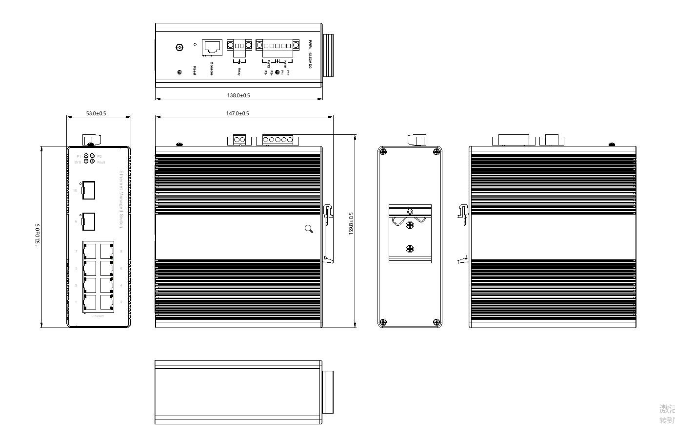

Order Information
Specification | Model No.
L2 Managed Industrial Switch  8 Port 10/100/1000Base TX+4 Port 100/1000 SFP | EL84MGI V3

