EL1160F 16-Port Fast Industrial Switch

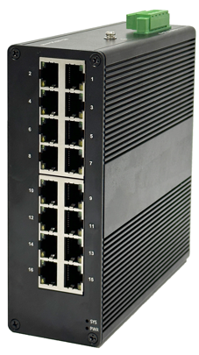
EL1160F is a converging integrated industrial Ethernet un-managed switch independently developed by our company. This product is mainly developed for the application of point-to-point networks, star networks, tree networks and chain networks in the industrial field. It supports 16-Port 10/100Base-TX. This product has a high-performance switching engine, a wavy aluminum alloy shell with an IP40 protection level, a fanless design and an efficient heat dissipation surface, and over-current, over-voltage and EMC protection for the loading power input port. The RJ45 port is equipped with excellent EMC protection performance, so that the series of products can adapt to harsh and dangerous industrial environments. Therefore, it can provide reliable and convenient solutions for users’ Ethernet equipment networking.
Interface
- 16*10/100BaseT(X),Automatic detection, Full/half duplex MDI/MDI-x adaptive

Industrial conformance
- 12V to 52V DC, redundant power input
- -40℃ to 75℃ operating temperature
- IP40 aluminum housing
- Supports 6KV DC Ethernet ESD protection
- Supports 6KV DC EFT protection for power line
- Free Fall, Shock and Vibration Stability
- DIN-rail hardware design
SPECIFICATIONS:
Model No. | EL1160F
Product description | 16-Port Fast unmanaged Industrial Ethernet Switch
Port Description | 16-Port RJ45 connector
Ethernet interface
RJ45 Ports | 10/100BaseT(X),Automatic detection,Full/half duplex MDI/MDI-x adaptive
Standards
Network Protocols | IEEE802.3 10BASE-T; 100BASE-T IEEE802.3i 10Base-T;IEEE802.3u;IEEE802.3x;
Twisted Pair | 10BASE-T: Cat3,4,5 UTP(≤100 meter)  100BASE-TX: Cat5 or later UTP(≤100 meter)
Switch Properties
Processing Type: | Store and Forward
MAC Table Size | 16K
Packet Buffer Size | 4Mbit
Bandwidth | 14.8G
Switching Delay | ＜10μs
Power Consume | ＜10Watts
Power Parameters
Power | Connection: 1 removable 5-contact terminal block(s)  Input voltage: DC12 to 52V redundant dual inputs support reverse connection protection
LED Indicator | Power: Green  Link: Green
Physical Characteristics
Enclosure | Wavy aluminum alloy
Protection level | IP40
Dimensions | 150x 126x 53mm (length x width x height)
Weigh | 0.7kg
Installation | Push-in DIN rail
Environmental Limits
Operating Temperature | -40～75℃ （-40～185 °F）
Storage Temperature | -40 to 85°C (-40 to 185°F)
Ambient Relative Humidity | 5 to 95% (non-condensing)
Standards and Certifications
Safety | EN 62368-1(LVD)
EMI | FCC Part 15 Subpart B Class A，EN 55032 Class A
EMS | IEC(EN)61000-4-2(ESD): ±8kV Contact, ±8kV Indirect,±15kV Air  IEC(EN)61000-4-3(RS):10V/m(80～1000MHz)  IEC(EN)61000-4-4(EFT): power line:±4kV; data line:±2kV  IEC(EN)61000-4-5(Surge): power:±6kV CM/±4kV DM; data:±4kV  IEC(EN)61000-4-6(RF conduction):3V(10kHz～150kHz),10V(150kHz～80MHz)  IEC(EN)61000-4-16(Common mode conduction):30V cont. 300V,1s  IEC(EN )61000-4-8
Shock | IEC 60068-2-27
Freefall | IEC 60068-2-32
Vibration | IEC 60068-2-6
MTBF
Time | 300 000hrs
Warranty
Warranty Period | 5 years

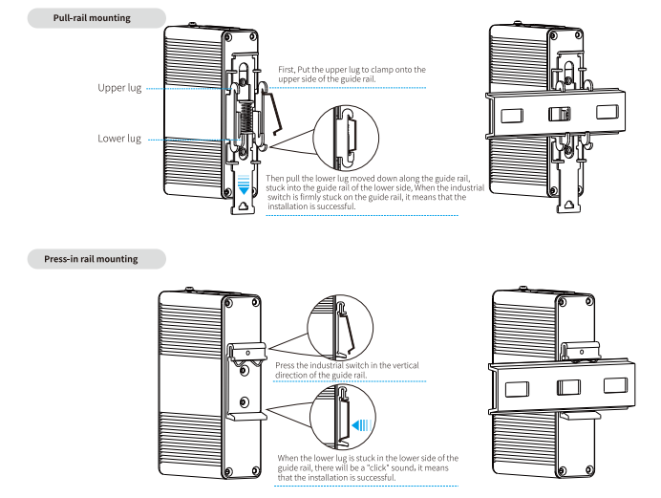
Installation method

