EL1082FG-SFP 8-Port 10/100 RJ45+2G SFP Industrial Switch

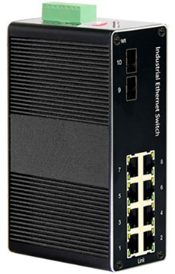
EL1082FG-SFP is a photoelectric convergence integrated industrial Ethernet seamless redundant ring switch independently developed by our company. The product is mainly developed for the application of point-to-point network, star network, tree network, chain network and ring network in the industrial field. It has 8 10/100Base-TX RJ45 ports and 2 1000Base-FX optical ports (SC, ST, FC, SFP), supports one-click HSR highly reliable seamless redundancy protocol, one-click VLAN, plug and play, and requires no configuration. This switch support HSR ring topology with one click (a ring with 3Pcs or 3Pcs+), zero recovery time, support convergence time of 50 nodes ≤6MS, 5,000 times faster than RSTP. All ports support full-line speed forwarding, its high-performance switching engine, with IP40 protection grade housing, fanless design efficient wavy aluminum alloy housing cooling surface, power input end overcurrent, over-voltage and EMC protection, RJ45 port excellent EMC protection performance, making the series of products can adapt to harsh and dangerous industrial environment. Provide reliable and convenient solutions for users' Ethernet devices networking.
Interface
- 8*10/100BaseT(X),Automatic detection, Full/half duplex MDI/MDI-x adaptive
- 2*1000Base-FX Port (SFP/ SC20A/SC20B)
Industrial conformance
- 12V to 52V DC, redundant power input
- -40℃ to 75℃ operating temperature
- IP40 aluminum housing
- Supports 6KV DC Ethernet ESD protection
- Supports 6KV DC EFT protection for power line
- Free Fall, Shock and Vibration Stability
- DIN-rail hardware design
SPECIFICATIONS:
Product Name | 8-Port 100Mbps RJ45+2 Port 1000Mbps SFP Industrial Switch
Model No. | EL1082FG-SFP
Ethernet interface
RJ45 Port | 8*10/100BaseT(X),Automatic detection, Full/half duplex MDI/MDI-x adaptive
Optical port | 2*1000Base-FX port SFP uplink  (Support 1*9 fixed optical SC,ST,FC interface, optional )
Power Parameters
Power | Connection: 1 removable 5-contact terminal block(s)  Input voltage: DC12 to 52V redundant power  support reverse connection protection
LED Indicator | Power: Green  Link: Green
Standards
Network Protocols | IEEE802.3-10BaseT、IEEE802.3u-100BaseTX/100Base-FX、IEEE802.3x-Flow Control、IEEE802.3z-1000BaseLX、IEEE802.3ab-1000BaseTX、IEEE802.1ab、IEEE802.1D-Spanning Tree Protocol、IEEE802.1w-Rapid Spanning Tree Protoco、APS  IEEE802.1Q -VLAN Tagging、 IEEE802.1p -Class of Service、IEEE802.1X-Port Based Network Access Control
Twisted Pair | 10BASE-T: Cat3,4,5 UTP(≤100 meter)  100BASE-TX: Cat5 or later UTP(≤100 meter)
One-click switcher | Switcher for HSR (RING connection)  Switcher for Vlan Isolation between downlink port
Switch Properties
Processing Type: | Store and Forward
MAC Table Size | 8K
Packet Buffer Size | 4Mbit
Bandwidth | 26G
Switching Delay | < 10μs
Power Consume | ≤ 5W
Physical Characteristics
Protection level | IP40
Enclosure | Wavy aluminum alloy
Installation | Push-in DIN rail
Weigh | 1.0kg
Dimensions | 150x125x53mm（length x width x height)
Environmental Limits
Working temperature | -40～75℃ （-40～167 °F）
Storage Temperature (package included) | -40 to 85°C (-40 to 185°F)
Ambient Relative Humidity | 5 to 95% (non-condensing)
Standards and Certifications
Safety | EN 62368-1(LVD)
EMI | FCC Part 15 Subpart B Class A，EN 55032 Class A
EMS | IEC(EN)61000-4-2(ESD): ±8kV Contact, ±8kV Indirect,±15kV Air  IEC(EN)61000-4-3(RS):10V/m(80～1000MHz)  IEC(EN)61000-4-4(EFT): power line:±4kV; data line:±2kV  IEC(EN)61000-4-5(Surge): power:±6kV CM/±4kV DM; data:±4kV  IEC(EN)61000-4-6(RF conduction):3V(10kHz～150kHz),10V(150kHz～80MHz)  IEC(EN)61000-4-16(Common mode conduction):30V cont. 300V,1s  IEC(EN )61000-4-8
Shock | IEC 60068-2-27
Freefall | IEC 60068-2-32
Vibration | IEC 60068-2-6
MTBF
Time | 300 000hrs
Warranty
Warranty Period | 5years

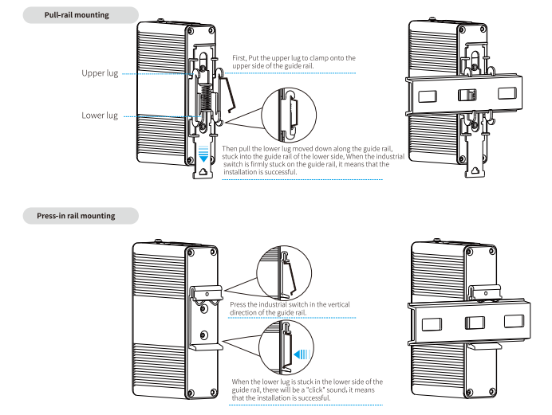
Installation method

Order Information
Specification | Model No.
8-Port 100Mbps RJ45+2 Port 1000Mbps SFP Industrial Switch | EL1082FG-SFP
8-Port 100Mbps RJ45+1*9 fixed optical Industrial Switch SM 1310nm, dual fiber, SC 20Km | EL1082FG-SC20
8-Port 100Mbps RJ45+1*9 fixed optical Industrial Switch SM 1310nm, single fiber, SC 20Km | EL1082FG-SC20A/SC20B
8-Port 100Mbps RJ45+1*9 fixed optical Industrial Switch SM 1310nm, dual fiber, ST 20Km | EL1082FG-ST20
8-Port 100Mbps RJ45+1*9 fixed optical Industrial Switch SM 1310nm, single fiber, ST 20Km | EL1082FG-ST20A/ST20B
8-Port 100Mbps RJ45+1*9 fixed optical Industrial Switch SM 1310nm, dual fiber, FC 20Km | EL1082FG-FC20
8-Port 100Mbps RJ45+1*9 fixed optical Industrial Switch SM 1310nm, single fiber, FC 20Km | EL1082FG-FC20A/FC20B

