EL1042F-SFP 4-Port RJ45+2 SFP Fast Industrial Switch

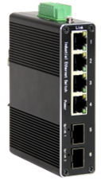
EL1042F-SFP is an integrated industrial switch (Industrial media converter) with 4 Port RJ45 100Mbps+2 Port SFP uplink. This product is mainly developed for the application of point-to-point networks, star networks, tree networks and chain networks in the industrial field. The longest optical communication distance can reach 120KM. Its high-performance switching engine has an IP40 protection-grade casing, a fanless design and an efficient corrugated aluminum alloy casing heat dissipation surface. The power input end has over-current, over-voltage and EMC protection, and the RJ45 port has excellent EMC protection performance, making this series of products able to adapt to harsh and dangerous industrial environments. Provide reliable and convenient solutions for users' Ethernet device networking.
Interface
- 4*10/100BaseT(X),Automatic detection, Full/half duplex MDI/MDI-x adaptive
- 2*100Base-FX Port , SFP
Industrial conformance
- 9V to 52V DC, redundant power input
- -40℃ to 75℃ operating temperature
- IP40 aluminum housing
- Supports 6KV DC Ethernet ESD protection
- Supports 6KV DC EFT protection for power line
- Free Fall, Shock and Vibration Stability
- DIN-rail hardware design
SPECIFICATIONS:
Product Name | 4 Port RJ45+2 Port SFP Industrial Switch
Model No. | EL1042F-SFP
Ethernet interface
RJ45 Port | 4*10/100BaseT(X),Automatic detection, Full/half duplex MDI/MDI-x adaptive
Optical port | 2*100Base-FX SFP
Power Parameters
Power | Connection: 1x removable 5-contact terminal block(s)  Input voltage: DC9 to 52V redundant power support reverse connection protection
LED Indicator | Power: Green  Link: Green
Standards
Network Protocols | IEEE802.3 10BASE-T;100BASE-T IEEE802.3i 10Base-T;IEEE802.3u;  IEEE802.3x;
Twisted Pair | 10BASE-T: Cat3,4,5 UTP(≤100 meter)  100BASE-TX: Cat5 or later UTP(≤100 meter)
Switch Properties
Processing Type: | Store and Forward
MAC Table Size | 2K
Packet Buffer Size | 2Mbit
Bandwidth | 1.6G
Switching Delay | ＜10μs
Power Consume | ＜5W
Physical Characteristics
Protection level | IP40
Enclosure | Wavy aluminum alloy
Installation | Push-in DIN rail
Weigh | 0.4kg
Dimensions | 115x70x30mm（length x width x height)
Environmental Limits
Working temperature | -40～75℃ （-40～167 °F）
Storage Temperature (package included) | -40 to 85°C (-40 to 185°F)
Ambient Relative Humidity | 5 to 95% (non-condensing)
Standards and Certifications
Safety | EN 62368-1(LVD)
EMI | FCC Part 15 Subpart B Class A, EN 55032 Class A
EMS | IEC(EN)61000-4-2(ESD): ±8kV Contact, ±8kV Indirect,±15kV Air  IEC(EN)61000-4-3(RS):10V/m(80～1000MHz)  IEC(EN)61000-4-4(EFT): power line:±4kV; data line:±2kV  IEC(EN)61000-4-5(Surge): power:±6kV CM/±4kV DM; data:±4kV  IEC(EN)61000-4-6(RF conduction):3V(10kHz～150kHz),10V(150kHz～80MHz)  IEC(EN)61000-4-16(Common mode conduction):30V cont. 300V,1s  IEC(EN )61000-4-8
Shock | IEC 60068-2-27
Freefall | IEC 60068-2-32
Vibration | IEC 60068-2-6
MTBF
Time | 300 000hrs
Warranty
Warranty Period | 5years

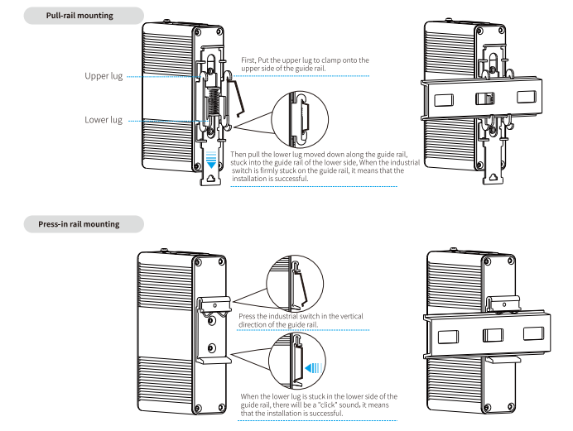
Installation method

Booking Information:
Model No. | Specification
EL1042F-SFP | 4 Port 10/100 Base -T +2-Port optical SFP Fast Industrial Switch
EL1042F-SC2 | 4 Port 10/100 Base -T +2-Port optical 1*9 (Multi Mode, (Tx/Rx1310nm), Dual fiber, SC2) Fast Industrial Switch, ST/FC Interface is optional
EL1042F-SC20 | 4 Port 10/100 Base -T +2-Port optical 1*9 (Single Mode, (Tx/Rx1310nm), Dual fiber, SC20) Fast Industrial Switch, ST/FC Interface is optional
EL1042F-SC20A | 4 Port 10/100 Base -T +2-Port optical 1*9 (Single Mode, (Rx1310nm/A), Single fiber, SC20) Fast Industrial Switch, ST/FC Interface is optional
EL1042F-SC20B | 4 Port 10/100 Base -T +2-Port optical 1*9 (Single Mode, (Tx1550nm/B), Single fiber, SC20) Fast Industrial Switch, ST/FC Interface is optional

